EXPLORING LEADERSHIP AND POWER VIRTUES IN NIGERIA THROUGH THE LENS OF FEMI ADEBAYO'S SEVEN DOORS
Ondo Journal of Arts, Faculty of Arts, Adeyemi Federal University of Education, Ondo. Vol. 2. No. 1, 2026

Introduction
T
Exploring Leadership and Power Virtues in Nigeria through the Lens of Femi Adebayo's Seven Doors

Abstract
Kazeem RUFAI-AHMAD Ph.D.
Abolade Olawale FAKAYODE and
Moyosola Eri-iyanuoluwa OJONIYI
he issue of leadership is a global phenomenon. While some countries, institutions and organisations are progressing socially, financially, economically, and culturally, others are
facing the challenges of leadership. Leadership as an important aspect of management is crucial to the world development because “the world needs outstanding leaders, who are required to lead people and

Leadership in post-colonial Nigeria is a phenomenon that requires
the attention of all and sundry because Nigeria is a nation in dire need of visionary, proactive, and resilient leaders who are ready to sacrifice for the people. Although, the quest for a good leader is not peculiar to Nigeria alone, however, Nigeria is not exonerated from leadership issues as seen in recent times. It is on this backdrop that the paper examines leadership and power virtues in Femi Adebayo's Seven Doors. The justification for the choice of the movie lies on the leadership skills and power virtues inherent in the movie. The paper adopted qualitative research through descriptive and content analysis methods to identify key leadership patterns and ethical frameworks represented in the film. It is revealed in the movie that effective leadership in nation building, institutional governance and organisational restructuring depend largely on leadership capability, confidence, influence, sacrifice, spiritual engagement, and power virtues such as courage, strength, patience, self-control, moral uprightness and integrity, stewardship and steadfastness as demonstrated in Seven Doors. The film further interrogates the tension between personal desire and communal obligation within traditional Yoruba socio-political structures. The paper concluded that Seven Doors offers a culturally grounded model of transformational leadership that integrates indigenous knowledge systems with contemporary governance needs in Nigeria.
Key words: Leadership, Institutional governance, Power, Virtue, Seven Doors
organisations through the ever dynamic and complex environment.” (Asikhia, Akpa & Abraham, 2021, p. 254). There are various patterns of leadership which have been practiced in both advanced and developing nations such as Autocratic, Democratic, Laissez Faire, Charismatic and Bureaucratic (Ngosi & Amangala, 2023). These leadership patterns are orchestrated by an individual guiding principles, experiences, educational qualifications, and willingness to uphold the constitution, norms, values, and the tradition as the case in the traditional society.
228
Series of movies in the Nigerian home video industry have addressed leadership issues and power virtues as regards the Nigerian nation. Some of these movies have also highlighted different patterns or forms of leadership with their attendant conundrums. Among them are movies such as Saworoide (1999), Agogo Eewo (2002), Black November (2012), '76 (2016), 4th Republic (2019), House of Gaa (2024), Funmilayo Ransome-Kuti (2024) and Femi Adebayo's Seven Doors (2024) which is the focus of this paper. The question of leadership and power virtues permeate all facet of human endeavours, from academics, banking, commerce, politics, and education to family affairs. Asikhia et al. (2021, p. 254) further posit that “leadership is considered a complex and dynamic concept, and has been shaped by various global forces from politics to world affairs.”
Virtue is a common phenomenon in the ways human beings relate with one another. It is a strong pillar in the existence of man. Therefore, the concept of virtue can either be used to promote
229

Ondo Journal of Arts, Faculty of Arts, Adeyemi Federal University of Education, Ondo. Vol. 2. No. 1, 2026
Exploring Leadership and Power Virtues in Nigeria through the Lens of Femi Adebayo's Seven Doors
Ondo Journal of Arts, Faculty of Arts, Adeyemi Federal University of Education, Ondo. Vol. 2. No. 1, 2026
Exploring Leadership and Power Virtues in Nigeria through the Lens of Femi Adebayo's Seven Doors

humanity or draw the progress of the society backward. The power virtues have to do with will power especially from the perspectives of someone who occupies a leadership position. The concept of power virtues is a demonstration of highly acceptable qualities and skills which a leader possesses to retain power and exercise continuous influence on his subjects. Power virtues, relatively speaking, depict bravery, courage, worthiness, strength, patience, self-control and moral uprightness in the discharge of civil duties to the governed society. Desautels (2106, p.1) opines that:
Power and persons holding powerful social positions tend to behave in ways that correlate with certain virtues and vicious patterns of behaviours…that patterns of moral or vicious behaviours (habits) tied to those in powerful positions are upheld by a combination of motivational dispositions and situational factors and that although a strong and dominating sort of power can corrupt, an agentic power to effect social, political, and institutional change is necessary for the social-ethic virtues.
Effective nation building, institutional governance and organisational restructuring, therefore, depend largely on leadership quality, capacity and confidence. Agboola (2019, p. 35) also opines that “the task of nation building is a universal phenomenon that requires avid commitment and sacrifice because nations are important parts of modern society having replaced empires as the basic unit of human political organisation.” Much of the leadership challenges accrued to nation building in Nigeria today lies on “political, social and economic instability and the prevalence of ethnic, communal and religious crisis, which have bedeviled Nigerian socio-economic development.” (Anekwe, 2020, p. 1). These leadership challenges can be tackled by drawing inferences from the leadership tenets in Femi Adebayo's Seven Doors because
there lie the principles and qualities of leadership for change in the Nigerian society. Therefore, the paper examines leadership and power virtues as portrayed in Femi Adebayo's movie -Seven Doors.
230

Concepts of Leadership
Leadership, according to Odesanya (2024, p. 107) “is the capacity to affect the behaviour of individuals inside a group or organisation, establish objectives for the collective, devise strategies to achieve those objectives, and cultivate social norms within the group.” In exercising power to achieve set goals and objectives within a group, leaders engaged themselves in different styles of leadership. Among the prominent styles of leadership are autocratic style, democratic or participative style, Laissez-faire style and servant leadership style.
The autocratic leader sees himself as superior and domineering. All suggestions and admonitions from his subjects or followers usually fall on deaf ears. Ngosi & Amangala (2023, p. 479) assert that “an autocratic leader is often seen as someone that is well aware of his status and has little faith or trust in the subordinates.” From Ngosi and Amangala, it is obvious that an autocratic leadership has a pattern of not giving rooms for collective bargaining and individual opinions and participation are not recognised. The autocratic leadership style can be said to be inappropriate for governance in the Nigerian society, considering the ethnic and religious diversity of the Nigerian nation.
The direct opposite of autocracy is a democratic or participative leadership style. In this leadership style, the followers' initiative, opinions, and suggestions in the decision-making process on developmental projects are recognised by the leader. This style of leadership allows for active participation of citizens in governance. The leader does not see himself as a boss; he sees himself as a motivator. Ngosi & Amangala (2023, p. 480) further opine that within the democratic leadership pattern, “arguments and compliments are
231

Ondo Journal of Arts, Faculty of Arts, Adeyemi Federal University of Education, Ondo. Vol. 2. No. 1, 2026
Exploring Leadership and Power Virtues in Nigeria through the Lens of Femi Adebayo's Seven Doors
Ondo Journal of Arts, Faculty of Arts, Adeyemi Federal University of Education, Ondo. Vol. 2. No. 1, 2026
Exploring Leadership and Power Virtues in Nigeria through the Lens of Femi Adebayo's Seven Doors

offered critically, and within the community a sense of responsibility is created” in decision making process and policy formulation. Therefore, “the exercise of power, usually comes with the process of checks and balances.” (Kofoworola, 2015, p. 38).
In laissez-faire leadership, the leader does not assume an important role in leadership because he sees himself as not mandated to do so. This leadership style is termed “let it be” and is also referred to as “hands off style.” (Ngosi & Amangala, 2023, p. 480). Northam, Hipps & Mbaye (n.d, p. 34) also assert that “Laissez-faire leadership is non-leadership in which the outcomes are principally negative. People are not given any direction and they don't know what to do, so they don't do much of anything which may cause them to become unmotivated.”
The servant leadership style which was propounded as a theory in leadership by Robert Greenleaf, “suggests that truly effective leadership stems from focusing on the follower and not on the leader.” (Northam et al., n.d, p. 11). The aim of a servant leader is to serve his people wholeheartedly, catering to their immediate needs, and empathise with them through self-esteem and self-actualisation. Asikhia et al. (2021, p. 265) state that “servant leadership emphasises collaboration, trust, empathy and ethics…servant leadership shares power with the followers, put their needs first and also help them to attain their best performance level.” The leadership style of Oba Adedunjoye in Femi Adebayo's movie- Seven Doors, will be examined taking into cognisance the various leadership patterns. The aim is to establish his style of leadership within one of the leadership styles discussed above.

Leadership, Power, and Polygamy in Yoruba Traditional Society as Portrayed in Femi Adebayo's Movie- Seven Doors
In Yoruba traditional society, there is a nexus between being a leader, attaining powerful positions, and polygamy, especially as it
relates to the kingship positions in Yoruba land. The Yorubas believed that a king who would lead a community to attain a great feat must exercise power and control through polygamy because it is an avenue to command respect, influence, and recognition as a traditional leader. Jonas (2012, p.143), while citing Welch and Glick (1981) attests that “previous kings in Africa are not unknown to have had large numbers of wives as a mark of their exalted positions.” He further argues that polygamy is a “source of power and prestige in African societies. Therefore, the numerous children produced from a polygamous union can assist in building and strengthening a power base.”
232
Ajala, Adeyanju & Adebagbo (2025, p. 8) also affirm that the position of kingship is “profoundly ingrained in African societies as an institution that represents power, responsibility and moral integrity.” Gutterman (2023, p. 2) while citing Dickson et al., also states that “leadership involves “disproportionate influence” and notes that leadership roles around the world are universally associated with power and status.” Leadership, therefore, connotes responsibility and expectations for both the institution one is leading or representing and the community at the bottom of the leadership position. Leaders in Nigerian society are in position of power and authority with the expectations to lead positively, in order to attain the set goals and objectives of the community they are governing. This highlights the nexus between leadership, power, status, responsibility, governance and community engagements.
In Femi Adebayo's Seven Doors (2024), the motif of the door serves as the movie's central metaphor, encapsulating the narrative's psychological, cultural, and spiritual dimensions. As both title and recurring symbol, the “door” becomes a multivalent signifier representing thresholds, transitions, opportunities, and the existential choices that shape destiny. Within the cosmology of Yoruba thought, doors (ilékun) are not merely architectural structures but portals
233

Ondo Journal of Arts, Faculty of Arts, Adeyemi Federal University of Education, Ondo. Vol. 2. No. 1, 2026
Exploring Leadership and Power Virtues in Nigeria through the Lens of Femi Adebayo's Seven Doors
Ondo Journal of Arts, Faculty of Arts, Adeyemi Federal University of Education, Ondo. Vol. 2. No. 1, 2026
Exploring Leadership and Power Virtues in Nigeria through the Lens of Femi Adebayo's Seven Doors

between realms of existence i.e. the living and the ancestral, the seen and unseen. Adebayo's creative deployment of this metaphor invites an interpretive reading that situates the film within a broader discourse of African metaphysics, collective destiny, and the interpenetration of the sacred and the mundane (Abimbola; Soyinka, 1976).
At the narrative level, the “seven doors” refer to the seven wives the Yoruba king, Adedunjoye, must marry to appease ancestral spirits and break a generational curse. This literal meaning establishes the premise for a more layered allegory. Each “door” the king opens is both a physical act that is entering another marital union and a symbolic journey into a new moral and psychological state. The number seven itself carries profound spiritual resonance in African and Judeo-Christian traditions: it denotes completeness, cosmic order, and cyclical renewal (Awolalu, 1996). Thus, the “doors” become stages in an archetypal pilgrimage toward restoration and wholeness. The protagonist's passage through these doors mirrors the human soul's struggle to reconcile personal desire with ancestral obligation.
Symbolically, doors demarcate boundaries: they separate yet connect; they conceal yet reveal. In Seven Doors, this duality becomes an instrument for exploring the contradictions between love and duty, individual freedom and communal expectation. The king's first wife, Amaka, embodies emotional fidelity and intimacy, whereas the subsequent “doors” demand emotional detachment and portray ritual compliance. The “door”, therefore, functions as a paradox in the movie. It promises liberation from a curse, yet simultaneously entraps king Adedunjoye within the ritual cycles that deny human autonomy. The conceptual motif behind the coinage “seven doors” indicates the doors that King Adedunjoye must knock in order to experience peaceful reign and longevity on the throne. The seven doors here means that he must marry seven wives to continue
the circle created by his forebears. This is the beginning of the leadership ordeals experienced by Oba Adedunjoye in the movie.
234
235
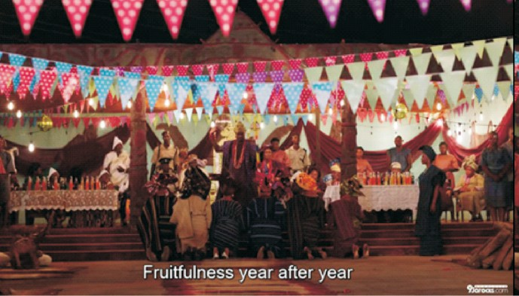

Fig. 1: Oba Adedunjoye during a wedding with the new six wives.
Source: Euphoria 360 [Episode 04, 32mins; 40secs].

In Yoruba tradition, the king (Oba) functions as both a political and spiritual mediator. His ascension is not merely symbolic but involves ritual performances intended to align him with divine authority, legitimising his rule while linking him to the ancestral and cosmic order (Johnson, 1921, p. 205; Fabunmi, 2010, p. 31). Seven Doors visually captures this sacred responsibility through drumming, chanting, libations, and the seclusion undergone by Oba Adedunjoye.
More so, the ethical dimension of ritual in leadership in traditional Yoruba society is emphasised throughout the film. Sacrifices, libations, and divination are portrayed not merely as formalities but as moral acts that restore communal equilibrium and peace (Iwa rere, righteous character) (Idowu, 1962, p. 30; Awolalu, 1996, p. 80). However, Oba Adedunjoye's failure to heed spiritual counsel specifically in knocking on the seven doors results in

Ondo Journal of Arts, Faculty of Arts, Adeyemi Federal University of Education, Ondo. Vol. 2. No. 1, 2026
Exploring Leadership and Power Virtues in Nigeria through the Lens of Femi Adebayo's Seven Doors
Ondo Journal of Arts, Faculty of Arts, Adeyemi Federal University of Education, Ondo. Vol. 2. No. 1, 2026
Exploring Leadership and Power Virtues in Nigeria through the Lens of Femi Adebayo's Seven Doors

disorder, whereas compliance with ritual obligations leads to restoration and cosmic alignment. Femi Adebayo, thus, demonstrates that authentic spiritual engagement, performed with moral integrity, is essential for leadership in order to resolve both human and cosmic conflict in the society.
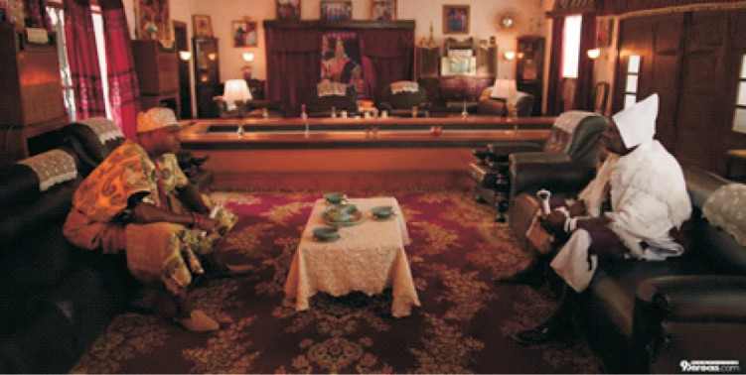
Fig. 2: Oba Adedunjoye and the Ifa priest discussing how to restore peace to Ilara Kingdom. Source: Euphoria 360 [Episode
04, 04mins; 37secs].

The triad of love, sacrifice, and temptation in Seven Doors provides the narrative's ethical and emotional framework, highlighting the moral and spiritual negotiation inherent in human existence. In Yoruba cosmology, love (Ifẹ´) is not merely romantic attachment but embodies selfless, redemptive forces that sustain communal and spiritual harmony (Idowu, 1962, p.28; Abiodun, 2014, p. 63). Adedunjoye's capacity for love was expressed toward his family and community through the help rendered to his friend's father.
At the heart of Seven Doors lies a meditation on love as both a sincere human emotion and a contested resource within the power structures of marriage, politics and governance. In Yoruba dramatic
tradition, love is rarely portrayed in isolation; it is often entangled with social obligations, economic considerations, and spiritual demands (Osundare, 2019). Adebayo follows this pattern, presenting love as a force constantly tested by the trials of sacrifice and temptation which a responsible and committed leader must possess to uplift his people and community.
237
236
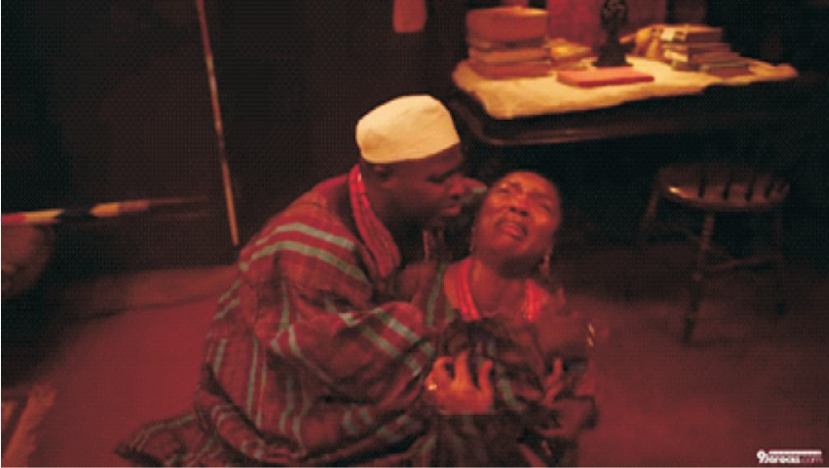
Fig. 3: Oba Adedunjoye consoling his first wife after his wedding to the six new wives. Source: Euphoria 360
[Episode 04, 35mins; 48secs]

In his quest to demonstrate love, commitment and some level of responsibilities to his people, Oba Adedunjoye faced with betrayal, corruption and dishonesty among his chiefs at the onset. His sincerity of purpose and resilience in the face of adversity qualifies him as a servant leader who has the utmost interest of his people at heart. Corruption is often employed as means of survival. It is an option that people explore when they think other options have failed.

Ondo Journal of Arts, Faculty of Arts, Adeyemi Federal University of Education, Ondo. Vol. 2. No. 1, 2026
Exploring Leadership and Power Virtues in Nigeria through the Lens of Femi Adebayo's Seven Doors
Ondo Journal of Arts, Faculty of Arts, Adeyemi Federal University of Education, Ondo. Vol. 2. No. 1, 2026
Exploring Leadership and Power Virtues in Nigeria through the Lens of Femi Adebayo's Seven Doors

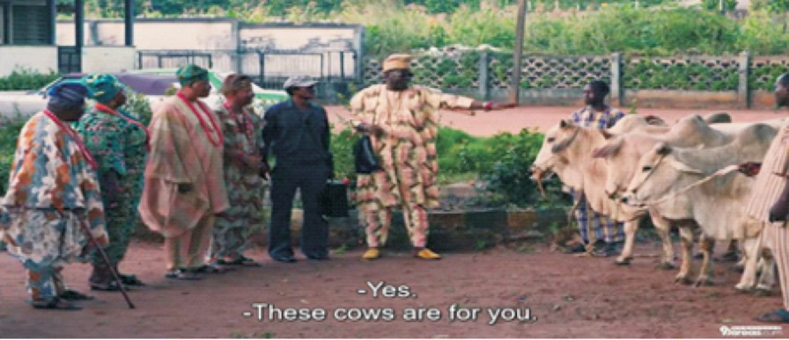
Fig. 4a: Fig.4b: Prince Adeeyo offers each chief of Ilara Kingdom a cow, soliciting for their support to get the throne. Source: Euphoria 360 [Episode, 23mins; 38secs]
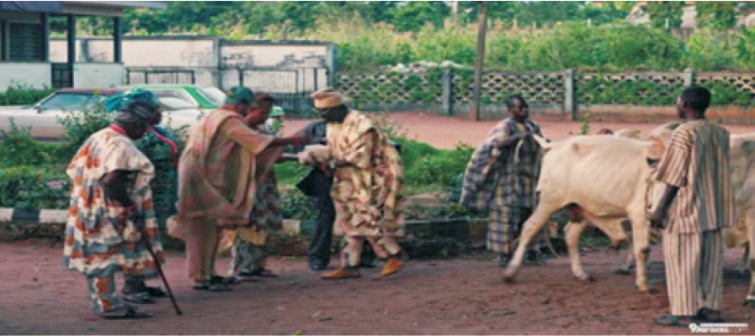
Fig.4b: Prince Adeeyo bribes the chiefs of Ilara Kingdom with cash, soliciting for their support to get the throne. Source: Euphoria 360 [Episode, 23mins; 38secs]

Corruption is an act inimical to building a sense of universal justice and equity in any system or society. The chiefs take advantage of the fact that they have no king at a time, to forcefully seize other
people's lands and properties. They carry out their nefarious activities with the help of the unemployed youths under their tutelage who go about with weapons to scare and threaten people of the community. Corruption and thuggery had its roots penetrated deep into the system when Oba Adedunjoye ascend the throne, and he takes drastic measures to stop it. The question “what does it mean to be a good person?” is always being asked, especially by Aristotle in the evolution of philosophy and the answer to it is based on personal perspective. This can be linked to the movie- Seven Doors, in which Oba Adedunjoye tries to do good, be a good person, even putting himself and his family on the line for the people he serves and leads but it does not seem to measure up.
The people's perspective is that he is a bad leader who should step down from the throne for someone better to take over. Everything he does, fighting corruption, ensuring peace, youth empowerment, counts as nothing to the people. Oba Adedunjoye repays the evil deed done towards Wale's father with good, and this gives him a second chance of life. Otherwise, he would have been killed by Opayemi of Olopade family. The king rebuilds the house of Wale's father which the chiefs destroyed while Wale's father in turn lays down his life for Oba Adedunjoye.
While servant leadership tenets are observed from the perspective of Oba Adedunjoye, the dark side of destructive leadership is observed in the spiritual role of Opayemi of Olopade family as the custodian of Opa (Sacred staff). He is supposed to be a spiritual leader on his own side, functioning as check and balance within the culture of Ilara people. However, Opayemi as a culture custodian allows himself to be used by prince Adeeyo and the chiefs against the King of Ilara kingdom. His inability to control his emotion, defiance behaviour, over ambition, and being incapacitated to stand firmly to uphold the tradition of the community by serving as check and balance, leads to his doom. An elderly woman warns him thus:
238
239

Ondo Journal of Arts, Faculty of Arts, Adeyemi Federal University of Education, Ondo. Vol. 2. No. 1, 2026
Exploring Leadership and Power Virtues in Nigeria through the Lens of Femi Adebayo's Seven Doors
Ondo Journal of Arts, Faculty of Arts, Adeyemi Federal University of Education, Ondo. Vol. 2. No. 1, 2026
Exploring Leadership and Power Virtues in Nigeria through the Lens of Femi Adebayo's Seven Doors

An elderly woman: Opayemi, don't be wicked.
The staff is meant to bring ease to the town.
The staff does not betray. [Episode 5, 11mins; 57 secs]

Leadership Lessons from Femi Adebayo's Seven Doors
Seven Doors addresses numerous thematic issues. One of these issues is leadership. The dynamics of leadership is observed through the administration of Ilara kingdom by Oba Adedunjoye, the Onilara of Ilara kingdom. From all indications, Seven Doors showcases leadership dynamism relevant to the contemporary Nigeria and global context. The movie, from the perspective of the administrative capacity and governance of the Yoruba traditional society, demonstrated the level of inclusiveness of the community in the administration. Furthermore, the show of fairness, justice, accountability and transparency through Oba Adedunjoye's administrative model, make Seven Doors a movie in which leadership tenets can be learned.
Oba Adedunjoye, having received complaint from people about his chiefs, calls for a council meeting and addresses that:
Oba Adedunjoye: Without wasting time, I summoned
you here.
You know it's been said that a town where there are no laws, there are no sins.
Chiefs: Yes, your Highness.
Oba Adedunjoye: And a town where laws exist, anyone
who goes against the laws must be punished according to the law.
Chiefs: Yes.
Oba Adedunjoye: And you know anyone who is ready to
cleanse the town, cannot be unfair or unjust, even when his own mother is involved. Isn't that right?
240
241
Chiefs: That is right, your Highness.
Oba Adedunjoye: From this moment onwards, there is
no room for “The king said”. There is no room for “The chiefs said”. There is no room for selling one piece of land to multiple people. There is no room for telling tales about land ownership. Anyone who possesses the right documents for the land owns the piece of land. Anyone who goes against this law, will be punished by the law. [Episode 2, 24mins; 58secs]

The show of empathy for whoever has a legal document to the ownership of land is a demonstration of fairness and justice. The chiefs have been using thugs to reclaim land from rightful owners. Oba Adedunjoye put an end to this through his humanity-based and progressive policy. A testimony to his policy of inclusiveness is shown when Wale and his father come to thank him for his support by rebuilding their house which the chiefs demolished. Oba Adedunjoye demonstrates the spirit of stewardship by taking care of the resources and people of his kingdom. The D.P.O. of Ilara police station related this at the security meeting with the king in council:

D.P.O.: Your Highness, if anyone had the same attitude as yours, the right judgement would have been upheld in this town. Concerning all those who bought plots of land, they all have the appropriate documents.

Ondo Journal of Arts, Faculty of Arts, Adeyemi Federal University of Education, Ondo. Vol. 2. No. 1, 2026
Exploring Leadership and Power Virtues in Nigeria through the Lens of Femi Adebayo's Seven Doors
Ondo Journal of Arts, Faculty of Arts, Adeyemi Federal University of Education, Ondo. Vol. 2. No. 1, 2026
Exploring Leadership and Power Virtues in Nigeria through the Lens of Femi Adebayo's Seven Doors

Oba Adedunjoye: Which means Asakoko and his boys
don't have any land documents. Lock them up. If their people are ready to buy another car or repair the damaged one, and if they are also ready to treat all that were wounded, then let's use this as a warning. But if they cannot do that, take them to court to face the law. [Episode 2: 37mins; 24secs]
In the process of upholding justice and building communal growth through community and youth empowerment, Oba Adedunjoye faced with calamity orchestrated by Aganju deity that leads to the loss of his daughter. As humans, facing unavoidable challenges can be frustrating. Oba Adedunjoye's long time neglect of knocking seven doors, resulted in death tolls to the community. This scenario created a face-off between him and the whole community to the extent that he nearly leave the throne: Adedunjoye while discussing with the Chief priest asks:

Oba Adedunjoye: So, what do I do? The deity rejected
the offering, yet the calamitous events have not stopped in Ilara town. I wanted to abdicate, you said it's not possible. What then is the way out? [Episode 3,19mins; 26secs]

In managing crisis within the community, Oba Adedunjoye employed consultation, collaboration and youth empowerment. The youths that the chiefs were using as thugs, were engaged through community empowerment. The king collaborated with investors by providing lands for industrial growth within the Ilara town. This decision portrayed him as a leader with foresight who conceptualised
and influenced through collaboration. In the face of protest by the Ilara people, Oba Adedunjoye is calm and addresses his people with wisdom. An authoritarian leader would have engaged force to deal with his people, instead, he seeks spiritual intervention to solve the communal problem. At the battle with Esusu, the intention of Oba Adedunjoye to serve his people was revealed when he calls his ancestor for support in order to triumph over the spirit of Esusu.
242
243

Oba Adedunjoye: Adekogbe o! Son of Adarisode, have
mercy on me. Don't let Esusu kill me. I'm fighting for Ilara. You built Ilara! Adekogbe don't allow it to crumble. [Episode 6, 38mins; 58secs]

Conclusion
From the foregoing, the paper has explored the context and type of leadership exhibited in Femi Adebayo's Seven Doors, situating it within the Nigeria's contemporary socio-political and cultural context. The paper emphasised that leadership is not just about occupying a position but requires the application of certain virtues, spiritualism, culture and sacrifice. The leadership tenets in the movie exemplify the dilemma between self-interest and community, as well as between political power and spiritual accountability.
The paper indicates that Seven Doors offers a cinematic framework through which Nigeria's leadership may be re-examined. The film presents a model of leadership that is interwoven with certain traditional values, which are crucial in shaping transformational leadership in the 21st century Nigeria. In this regard, the paper contributes to academic discourse by demonstrating that film is one of the potent instruments of socio-political enquiry, while suggesting that integrity, sacrifice, cultural sensitivity, and service-oriented leadership are also ideals for Nigerian society.

Ondo Journal of Arts, Faculty of Arts, Adeyemi Federal University of Education, Ondo. Vol. 2. No. 1, 2026
Exploring Leadership and Power Virtues in Nigeria through the Lens of Femi Adebayo's Seven Doors
Ondo Journal of Arts, Faculty of Arts, Adeyemi Federal University of Education, Ondo. Vol. 2. No. 1, 2026
Exploring Leadership and Power Virtues in Nigeria through the Lens of Femi Adebayo's Seven Doors

Furthermore, the paper reflects the attendant challenges associated with leadership in Nigeria. It reveals that effective leadership, both Nigerian and global contexts may require the demonstration of fairness, justice, transparency and accountability. Leadership in Nigeria, therefore, requires continuous stewardship in the effective management of human and material resources for the betterment of the people. Part of the measures for the attainment of this goal, is adequate consultation with stakeholders, collaboration with professionals and experts and youth engagement in the national polity. It can, therefore, be concluded that Seven Doors offers a culturally grounded model of transformational leadership that integrates indigenous knowledge systems with contemporary governance needs in Nigeria.

Recommendations
Drawing from the analysis of leadership and power virtues in Femi Adebayo's Seven Doors, the study offers the following recommendations:
- Nigeria leaders should integrate ethical leadership virtues such as integrity, accountability, empathy, and sacrifice into governance practices. Leaders should also prioritise inclusiveness, stakeholder consultation, and youth empowerment as mechanisms for sustainable development and social stability.
- Filmmakers are encouraged to produce narratives that not only entertain but also educate and challenge existing leadership paradigms within the society.
- Scholars should further explore the intersection of film studies, leadership theory, and African indigenous knowledge systems.
- Governmental and institutional bodies should recognise the role of cultural productions such as film in shaping civic consciousness.
References
244

Abimbola, W. (1976). Ifa: An exposition of Ifa literary corpus.
Oxford University Press.

Abiodun, R. (2014). Yoruba art and language: Seeking the African in African art. Cambridge University Press.

Adebayo, F. (Director). (2024). Seven Doors [Film]. Fespris Production.

Agboola, M. (2019). Nation-building and attitudinal constructs in Nigeria's post-colonial drama:

AbdulRasheed Adeoye's The Killers as a paradigm. In O. Ojediran, T. S. Arinde, & P. A.

Gborsong (Eds.), African culture and performance dynamics in the dramaturgy of AbdulRasheed Abiodun Adeoye (pp. 35–46). Department of Performing Arts, University of Ilorin and Department of Theatre and Film Studies, University of Cape Coast.

Ajala, A. T., Adeyanju, A. R., & Adebagbo, A. (2025). Tradition and culture: A reflection of African society in Femi Adebayo's film Seven doors. International Journal of Literature, Language and Linguistics, 8(2), 1–20.

Anekwe, I. R. (2020). Leadership challenges and Nigerian development: The issues and imperatives. International Journal of Academic Accounting, Finance and Management Research (IJAAFMR), 4(1), 1–5.
245

Ondo Journal of Arts, Faculty of Arts, Adeyemi Federal University of Education, Ondo. Vol. 2. No. 1, 2026
Exploring Leadership and Power Virtues in Nigeria through the Lens of Femi Adebayo's Seven Doors
Ondo Journal of Arts, Faculty of Arts, Adeyemi Federal University of Education, Ondo. Vol. 2. No. 1, 2026
Exploring Leadership and Power Virtues in Nigeria through the Lens of Femi Adebayo's Seven Doors

Asikhia, O., Akpa, V., & Abraham, A. A. (2021). Leadership: A review of definitions and theories. International Journal of Advances in Engineering and Management (IJAEM), 3 (1), 254–272.
Awolalu, J. O. (1996). Yoruba beliefs and sacrificial rites. Longman Desautels, P. (2016). Power, virtue, and vice. The Monist, 99(2), 128
143 . https://www.researchgate.net / publication/
299355227_Power_Virtue_Vice

Fabunmi, M. A. (2010). The role of traditional institutions in governance in Nigeria. Journal of Pan African Studies, 3(4), 30–44.

Gutterman, A. S. (2023). Definitions and conception of leadership. Retrieved March 2, 2026, from https://www.researchgate.net/ Publication/371169414_Definitions_and_Conceptions of_Leadership

Idowu, E. B. (1962). Olódùmarè: God in Yoruba belief. Longman.

Johnson, S. (1921). The history of the Yorubas: From the earliest times to the beginning of the British protectorate. Routledge & Kegan Paul.

Jonas, O. (2012). The practice of polygamy under the scheme of the Protocol to the African Charter on Human and People's Rights on the Rights of Women in Africa: A critical appraisal. Journal of African Studies and Development, 4(5), 142–149.
Kofoworola, Z. O. (2015). Art, theatre, performance and power: A case study of the derelict ideological impact in Nigeria. In Z. O. Kofoworola (Ed.), Rhythm of truth: An interdisciplinary approach to knowledge (pp. 27–55). Department of Performing Arts, University of Ilorin.
246
247

Ngosi, A. F., & Amangala, R. T. (2023). Leadership patterns and their impacts in an organisational setting. International Journal of Institutional Leadership, Policy and Management, 5 (4), 477–490.

Northam, S. W., Hipps, L. M., & Mbaye, H. A. D. (n.d.). Principles of leadership. University of North Georgia Press.

Odesanya, O. S. (2024). The challenges of leadership in Nigeria and its effects on development. International Journal of Innovative Legal and Political Studies, 12(3), 106–115.

Osundare, N. (2019). Yoruba drama and theatre: Cultural continuity and transformation. Kraft Books.

Soyinka, W. (1976). Myth, literature and the African world.
Cambridge University Press.

